Marshall Profiling Ltd

Pressing Tool Allowances

Mild Steel
Aluminium 5052
Stainless Steel 304 & 316
Steel
mm
mm
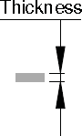 | 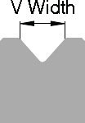 | 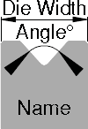 |  | 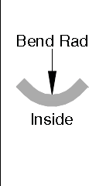 | 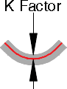 |  | 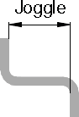 | 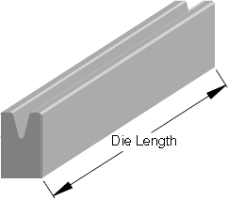
1 | 8 | 20mm 30° |  | 1.5 | 0.39 | 5.6 | 11.5 | 3050
 |  |  |  | 1.4 | 0.39
 |  |  |  | 1 | 0.6
1.2 | 8 | 20mm 30° |  | 1.5 | 0.35 | 5.6 | 11.5 | 3050
 |  |  |  | 1.4 | 0.37
 |  |  |  | 1.5 | 0.56
1.5 | 12 | 25mm 30° |  | 2.3 | 0.31 | 7.8 | 14.9 | 3050
 |  |  |  | 1.9 | 0.3
 |  |  |  | 2 | 0.54
2.0 | 16 | 30mm 30° | 30mm 86° | 3.1 | 0.34 | 9.5/11.5 | 18.3 | 2450 | 3050
 |  |  |  | 2.6 | 0.36
 |  |  |  | 2.6 | 0.57
2.5 | 20 | 30mm 86° |  | 3.9 | 0.35 | 12 | 19 | 3050
 |  |  |  | 3.2 | 0.36
 |  |  |  | 3.2 | 0.54
3.0 | 24 | 40mm 30° | 35mm 86° | 4.3 | 0.32 | 14.5/16.1 | 24.1 | 3050 | 3050
 |  |  |  | 3.9 | 0.36
 |  |  |  | 3.8 | 0.55
4.0 | 30 | 45mm 86° |  | 5.4 | 0.33 | 18 | 28 | 2300
 |  |  |  | 4.0 | 0.39 |  |  | 3050
 |  |  |  | 5.1 | 0.55 |  |  | 3050
5.0 | 40 | 50mm 40° |  | 6.9 | 0.31 | 24 | 32.2 | 2000
 |  |  |  | 5.1 | 0.35 |  |  | 3050
 |  |  |  | 6.2 | 0.44 |  |  | 3050
6.0 | 40 | 50mm 40° |  | 6.7 | 0.33 | 24 | 32.2 | 1400
 |  |  |  | 5.1 | 0.36 |  |  | 1700
 |  |  |  | 7.2 | 0.4 |  |  | 2800
8.0 | 62.5 | 120mm 40° |  | 10.4 | 0.28 | 41 | 72.9 | 2 X 250
 |  |  |  | 7.7 | 0.31
10 | 82.5 | 120mm 50° |  | 13.8 | 0.28 | 54 | 96.6 | 2 X 250
 |  |  |  | 10.6 | 0.28
12 | 102.5 | 120mm 60° |  | 17.8 | 0.26 | 66 | 120.4 | 2 X 250
 |  |  |  | 12.9 | 0.32
16 |  | 120mm  60°

Max thickness for crushed edge 2mm.
Any hole within folding area disturbs overall dimensions and may distort the part.
When using minimum joggle, consider tool height (if flange is longer than tool height include pre- bend).

